**CS5551: Advanced Software Engineering**

**Dept. of Computer Science Electrical Engineering**

**University of Missouri - Kansas City**

**Smart Health**

**By Team 7:**

|  |  |  |
| --- | --- | --- |
| **ClassID** | **Name** | **MailId** |
| 40 | Naga Sirisha, Sunkara | nsbz5@mail.umkc.edu |
| 32 | Vinay, Santhosham | vsvzw@mail.umkc.edu |
| 15 | Vineeth Reddy, Kottam | vkpcw@mail.umkc.edu |
| 28 | Venkata Bhavesh, Polareddy | vp5dt@mail.umkc.edu |

Video URL: <https://www.youtube.com/watch?v=b47tta1r7Ak>

GitHub URL: <https://github.com/vinaysanthosham/ASE_Project>

ZenHub URL: <https://github.com/vinaysanthosham/ASE_Project#boards>

**INDEX**

|  |  |
| --- | --- |
| **S.NO** | **Description** |
| 1 | INTRODUCTION |
|  | * 1. PROBLEM DEFINITION   2. PROPOSED SYSTEM   3. SOFTWARE AND HARDWARE REQUIREMENTS   4. ARCHITECTURE DIAGRAM   5. CLASS DIAGRAM |
| 2 | MODULE DESCRIPTION |
|  | 2.1 LOGIN AND REGISTRATION MODULE  2.2 HOME PAGE  2.3 HOW TO USE SYSTEM |
| 3 | ERROR HANDLING |
| 4 | SCREEN DUMPS |
| 5 | PROJECT MANAGEMENT REPORT |
| 6 | REFERNCES |

**CHAPTER 1**

**INTRODUCTION**

* 1. **PROBLEM DEFINITION:**

In our day to day life people are very busy in their work and they are neglecting their health. With our application user can check nearest pharmacy stores and locate them in the Google Maps. If the user is completely unaware of the drug he can check the side effects of the drug using our application

* 1. **PROPOSED SYSTEM:**

We are developing an application that will locate the pharmacy location based on our device location and it will display that locations on Google Maps with the help of Map Markers. Using Google cloud vision API, we are detecting text from the image and passing that text to OpenFDA drugs API and we will find the Side effects of the drugs. With the help of AR, we will display that side effects on the Augmented camera.

* 1. **SOFTWARE REQUIREMENTS:**
* IONIC
* HTML
* CSS
* TYPE SCRIPT
* VUFORIA
* UNITY
  1. **ARCHITECTURE DIAGRAM:**

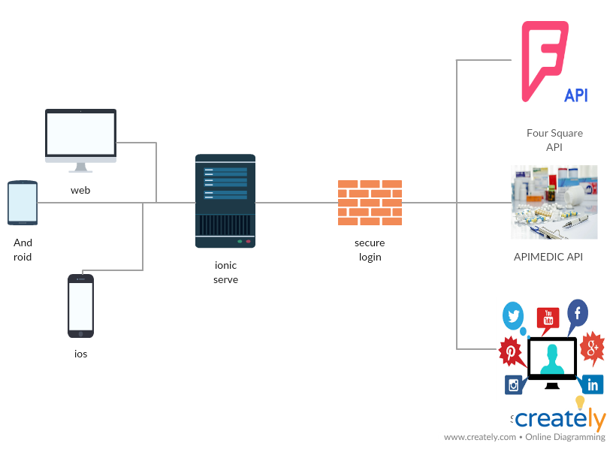

* 1. **CLASS DIAGRAM:**

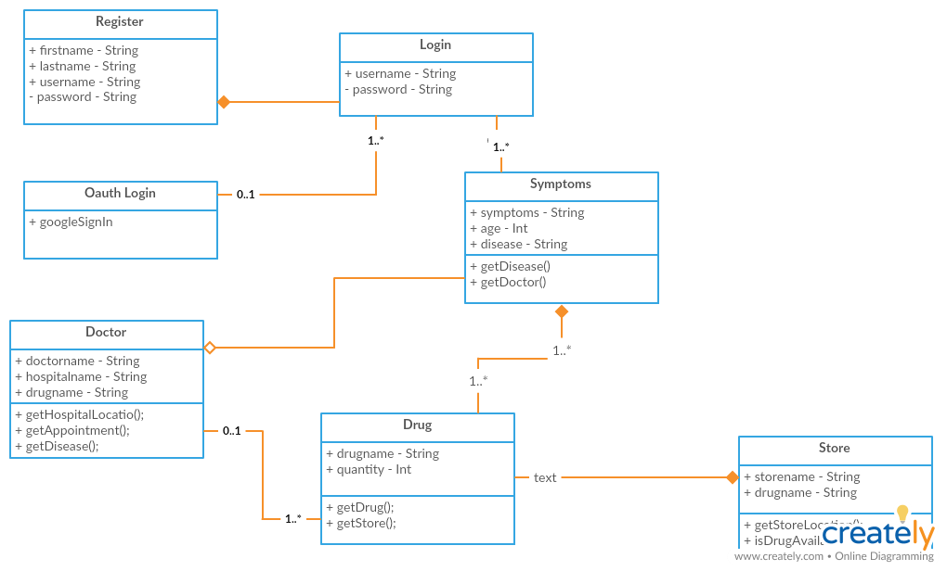

**CHAPTER 2**

**MODULE DESCRIPTION**

**2.1. LOGIN AND REGISTRATION MODULE:**

In our application we are having two tabs one is registration and another on is login tabs.

In Register Page, we are taking values of user like username, password, mail. We are storing these values in Google Firebase.

Validations:

* Fields can’t be empty
* Password and confirm password must match
* User must enter valid mail id.

In Login Page, we are retrieving these values from the Firebase and validating the user.

Validations:

* Fields can’t be empty
* Username & password must match to logged in.

**2.2. HOME PAGE MODULE:**

In this we are having three sub modules are there:

1. **Get nearest pharmacy**

Here we are retrieving the pharmacy locations by passing device location to the Four-Square API. Later we are displaying these locations on Google Maps using Google Maps API

1. **List of Drugs**

Here we are using drugs node module to display the available drugs. So that, user can see the available drugs.

1. **Side effects of the Drugs**

Here we are detecting the text from image and passing that text drugs API and retrieving the side effects of the drugs and displaying the user

**2.3 HOW TO USE SYSTEM**

**1. Register:**

To use the application, the user must register, the details of the user will be stored in the firebase. Here the user can’t leave the field empty and he should use valid mail to register and the password and confirm password must be same.

**2. Login:**

After the completion of registration, the user must login to the system with his own credentials. Here we are validating whether the fields must be empty or not. And the Username and password must match.

**3. Home Page:**

After Logging in, the user must be redirected to the home page where there are three tabs Get nearest pharmacy, Drug side effects and Drug list.

**4. Get nearest pharmacy:**

After Clicking the Get nearest pharmacy, the user must give location access to the application. Our application will pass the location to FOUR-SQUARE API and it will get the locations of the nearest pharmacy. Then these locations will be displayed on the Google Maps with the Help of Google Maps API.

**5. Get Side Effects:**

After clicking the side effects, the user is asked to capture the image and the application will detect the name of the drug from the image and it will pass that name to the OpenFDA drugs API and it will retrieve the side effects of the drugs and display to the user.

**6. List of Drugs:**

After clicking the list of drugs, we are using the drugs node module and displaying the list of available drugs. So that user can see what are the available drugs.

**CHAPTER 3**

**ERROR HANDLING**

**Register Page:**

Here we are doing following validations:

* Text fields can’t be empty
* Password and confirm password must be same
* Username must be unique
* User must register with valid mail Id

**Login Page:**

Here we are doing following validations:

* Text fields can’t be empty
* Username and password must match

**CHAPTER 4**

**SCREEN DUMPS**

1. **Login Page:**

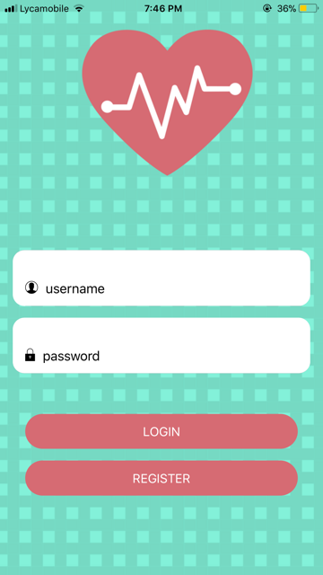

1. **Register Page:**

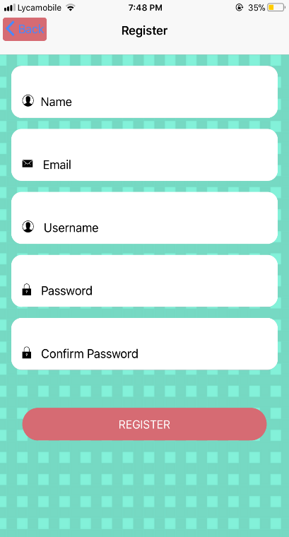

1. **Home Page:**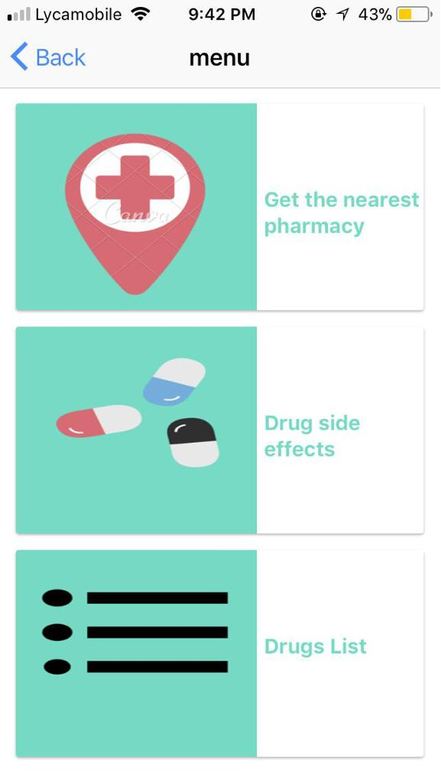
   1. **Get nearest pharmacy**
      1. **Four-Square API**

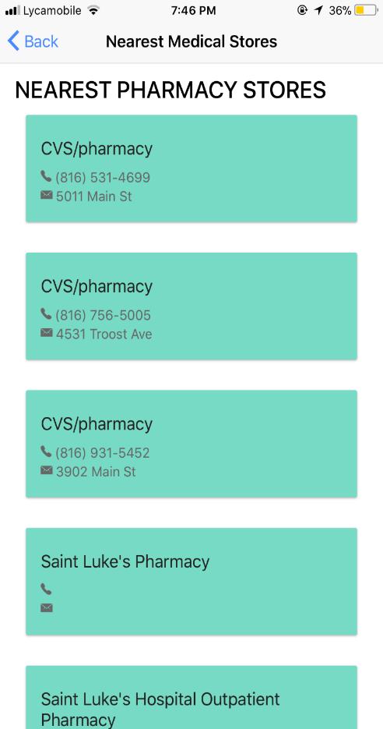

* + 1. **Google Maps API**

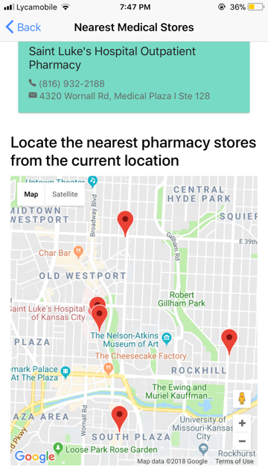

* 1. **Drug Side effects**
     1. **Google vision API**

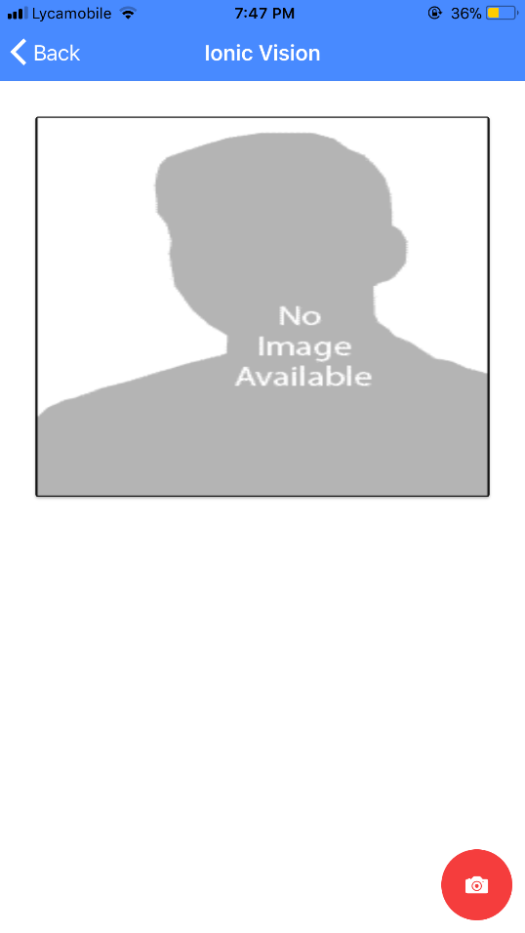

* + 1. **Drug Side effects API**

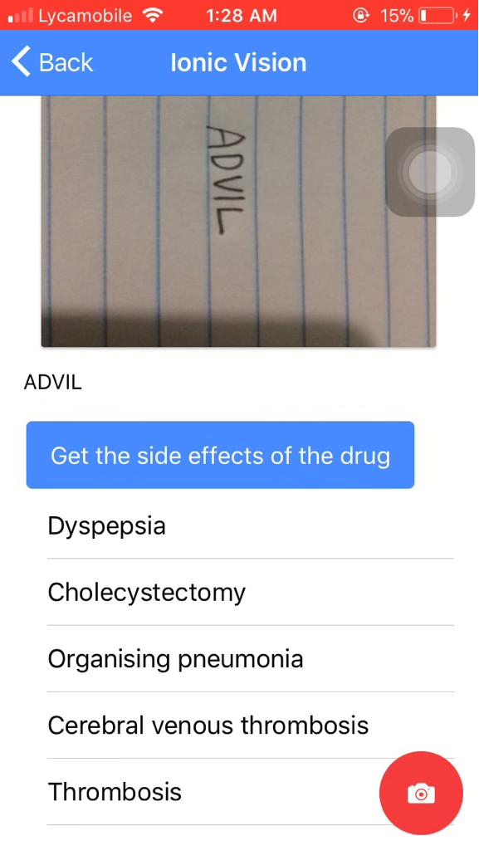

* 1. **Drug List**

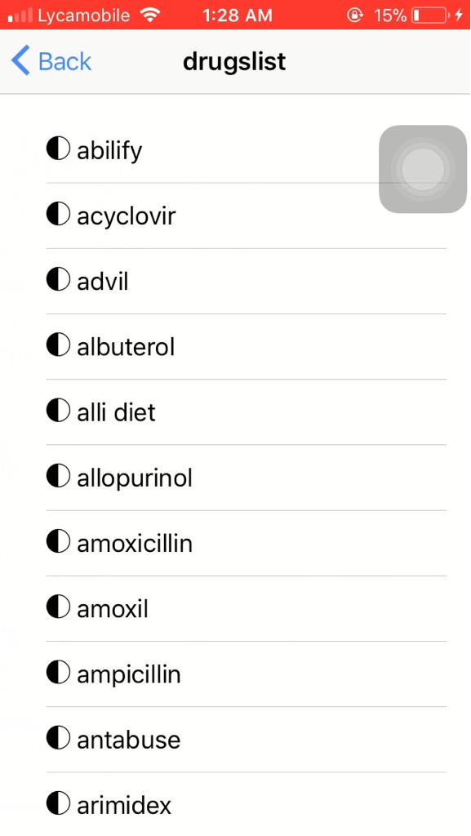

* 1. **AUGUMENTED REALITY**

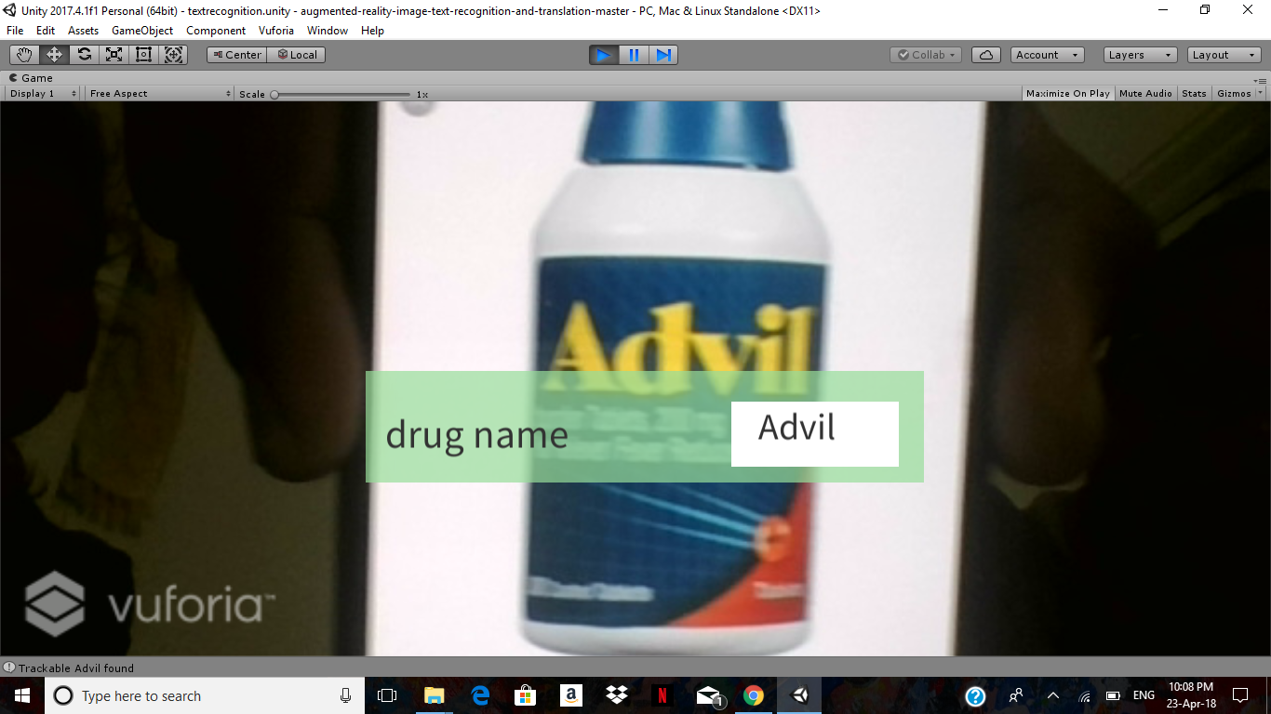

**CHAPTER 5**

**PROJECT MANAGEMENT REPORT**

**5.1 CONTRIBUTION CHART:**

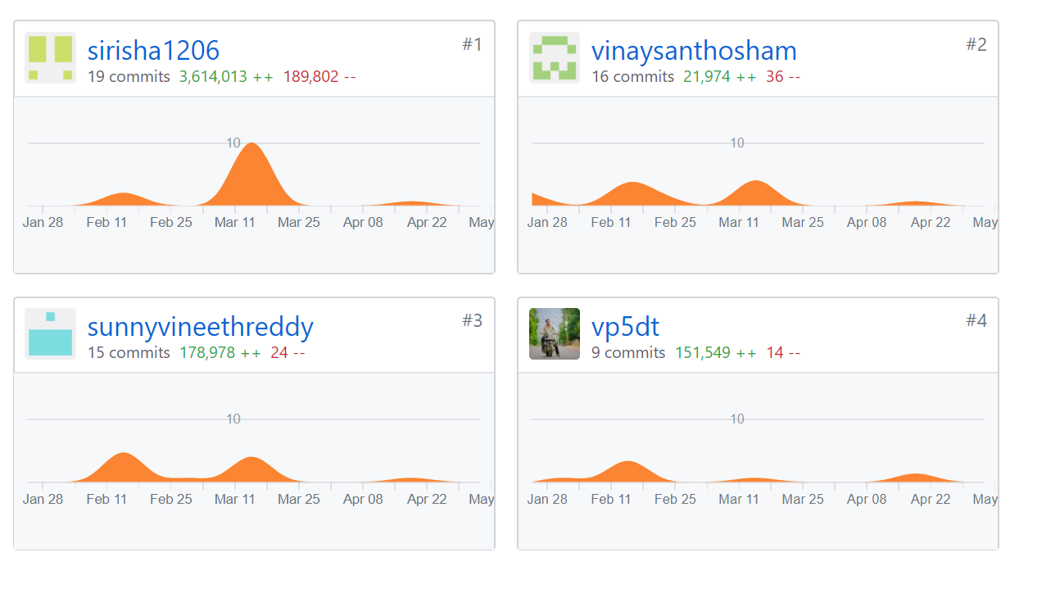

**5.2 TEAM MEMBERS CONTRIBUTION:**

**1. Naga Sirisha Sunkara:**25%

Text detection using google cloud vision API,Getting the side effects list using open fda API,UI design

1. **Bhavesh Polareddy:**25%

Login Screen with validations,AR,Text detetction using google cloud vision API

1. **Vinay Santhosham:**25%

Register screen with validations,Foursquare api to get the nearest pharmacy stores,Getting the drugs list using drugs node module

1. **Vineeth Reddy Kottam:**25%

Four square api google maps for displaying the nearest the pharmacy stores on the google map,AR.

**CHAPTER 6**

**REFERENCES**

* <https://foursquare.com/>
* <http://apimedic.com/>
* <https://creately.com/app/>
* <https://cloud.google.com/vision/>
* [https://www.sitepoint.com/image-recognition-with-the-google-vision-api-and- ionic/](https://www.sitepoint.com/image-recognition-with-the-google-vision-api-and-%20ionic/)

**Acknowledgement Statement**: The work has been completed under the guidance of Dr. Yugi Lee and TAs (Rohith Nagulapati, Sidrah Junaid, Nageswara Nandigam) in CS5551 Advanced Software Engineering, University of Missouri - Kansas City), Spring 2018.